**Assignment Three: The Labyrinth!**

In this assignment, you'll need to devise an **algorithm** to help the Scratch cat exit a labyrinthine maze. Remember what you've learned about using loops (repeat blocks) - these can clean up repeated code sections and make our programs much easier to understand.

Assignment:

1. Download the following maze image: (Maze.jpg) and upload it to Scratch as a background for a new project.

2. Create the following starting blocks to ensure our scratch cat starts at the same location each time:

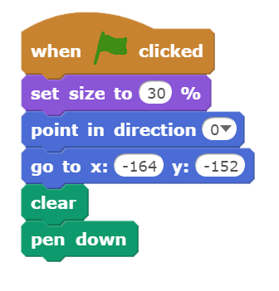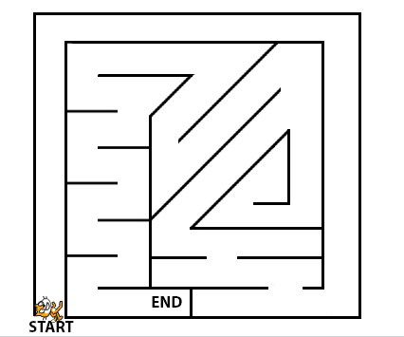

3. Help move the cat to the end location without crossing any of the labyrinth walls. To receive full credit for this assignment, you must be able to accomplish the task cited above **without using more than 40 blocks**(including the 6 setup blocks shown in #2).

**A FEW RULES:**

There are several blue MOVE blocks that allow you to solve this using coordinate locations. One of the goals of this challenge is to come up with an elegant solution through use of loops. To facilitate that, **the only blue movement blocks allowed are:**

**Move             Turn               Point in Direction**

*Extra for Experts*

Finishing it with 40 blocks was too easy? Take a closer look at your algorithm and the maze and see if you can come up with any **optimizations**to your solution. To earn the extra for experts challenge on this assignment, design a complete algorithm that uses less than 32 blocks.

What is the most concise solution you can devise? *The current shortest student solution is 26 blocks.*